# **54. VIRTUALIZATION, CLOUD ,CONTAINERS and VRF**

## **VIRTUAL SERVERS**

* Although Cisco is more known for networking **devices** (routers, switches, firewalls), they also offer **hardware servers** such as **UCS (Unified Computing System)**.
* The largest vendors of **hardware servers** include **Dell, EMC, HPE, and IBM**.

## **SERVERS BEFORE VIRTUALIZATION**

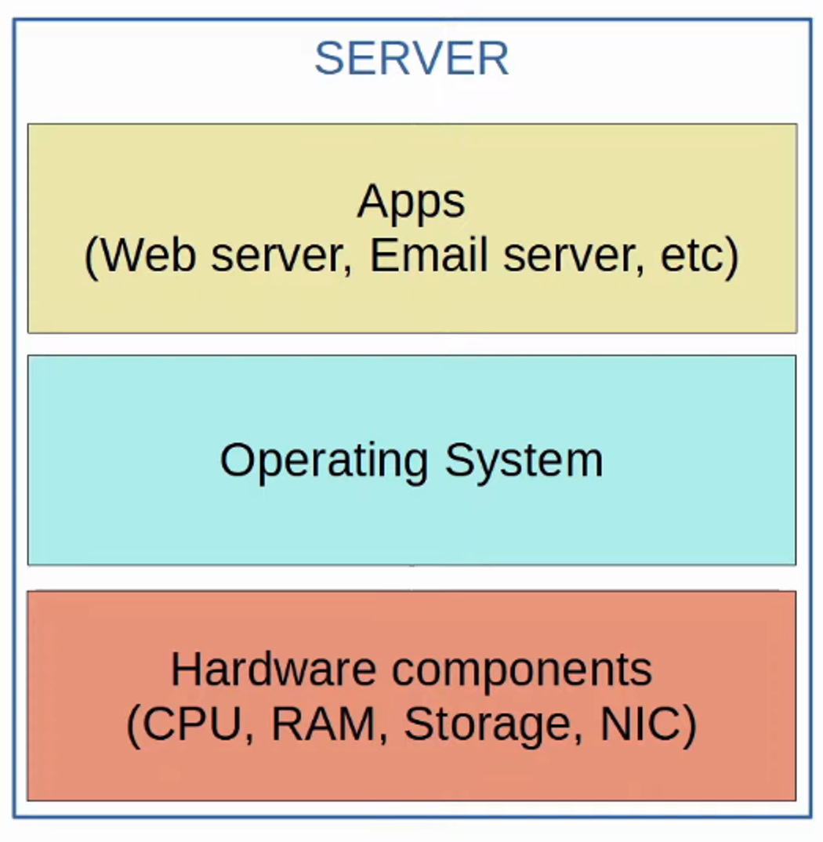

* Before **virtualization**, there was a **one-to-one** relationship between a **physical server** and an **operating system**.
* Within that **operating system**, applications providing **services** (such as a **web server, email server**, etc.) would run.
* Each **physical server** was dedicated to a specific service:
  + One for the **web server**
  + One for the **email server**
  + One for the **database server**
* **Inefficiencies:**
  + Each **physical server** is expensive and takes up space, power, etc.
  + The **resources** (CPU, RAM, storage, NIC) of each **physical server** are typically underutilized.

## **VIRTUALIZATION (TYPE 1 HYPERVISOR)**

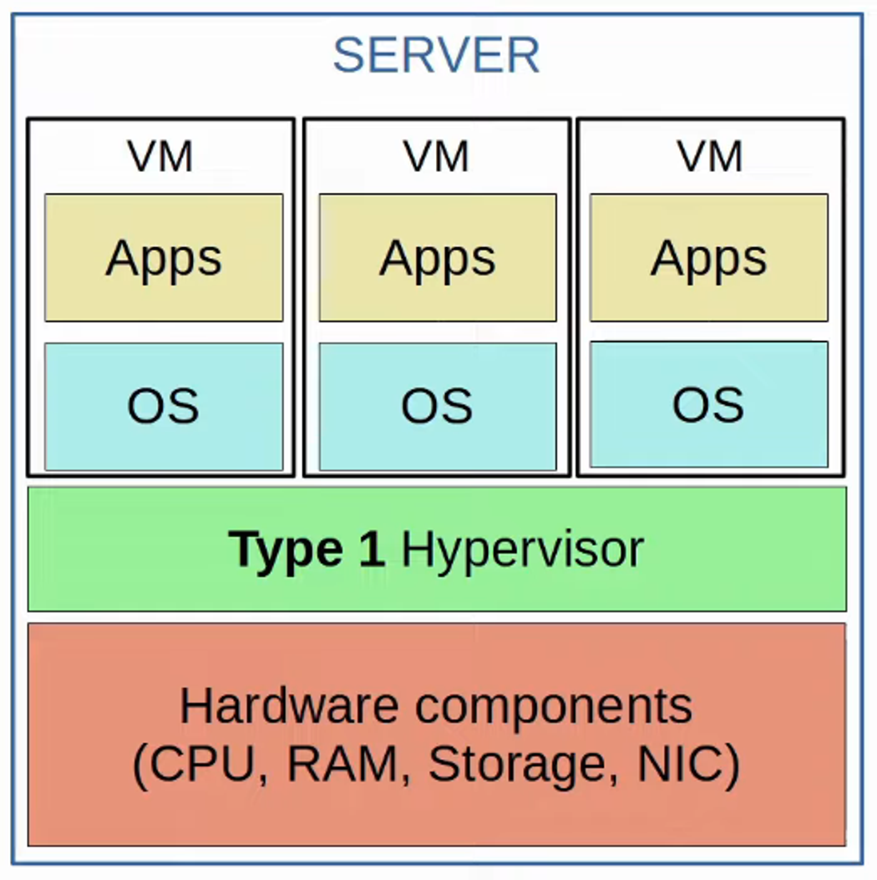

* **Virtualization** breaks the one-to-one relationship between **hardware** and **OS**, allowing multiple **OS instances** on a single **physical server**.
* Each instance is called a **VM (Virtual Machine)**.
* A **hypervisor** manages and allocates **hardware resources** (CPU, RAM, etc.) to each **VM**.
* Another name for a **hypervisor** is **VMM (Virtual Machine Monitor)**.
* **Type 1 Hypervisors** run **directly** on hardware (**bare-metal hypervisors**):
  + **Examples:** VMware ESXi, Microsoft Hyper-V.
* Used in **data center environments**.

## **VIRTUALIZATION (TYPE 2 HYPERVISOR)**

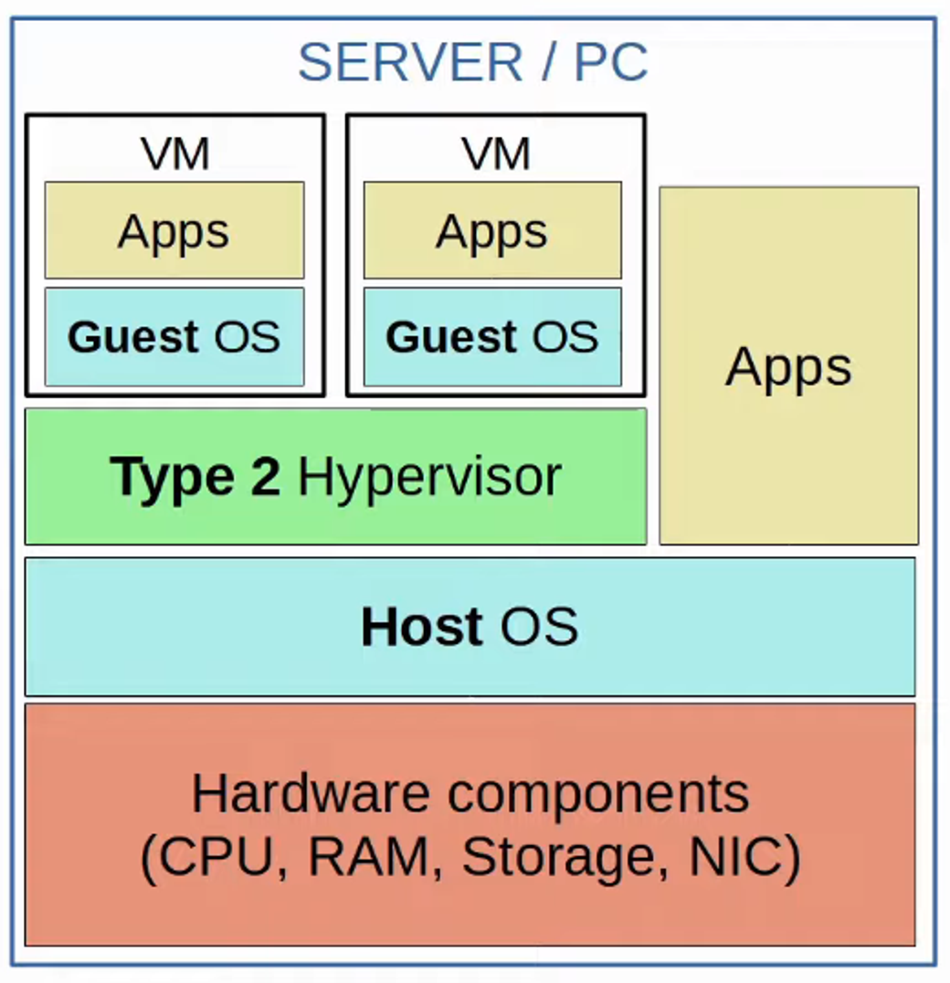

* **Type 2 Hypervisors** run as a **program on an OS**.
  + **Examples:** VMware Workstation, Oracle VirtualBox.
* The **OS running directly on hardware** is called the **Host OS**.
* The **OS running inside a VM** is called the **Guest OS**.
* Also known as **hosted hypervisors**.
* Common for **personal devices**, not **data centers**.

## **WHY VIRTUALIZATION?**

* **Partitioning:**
  + Run multiple OS instances on **one physical machine**.
  + Divide system resources between **virtual machines**.
* **Isolation:**
  + Provides **fault tolerance** and **security isolation**.
  + Maintains performance with advanced **resource controls**.
* **Encapsulation:**
  + Saves the entire **state** of a VM as files.
  + Allows easy **migration and replication** of VMs.
* **Hardware Independence:**
  + Deploy or migrate any **VM** to any **physical server**.

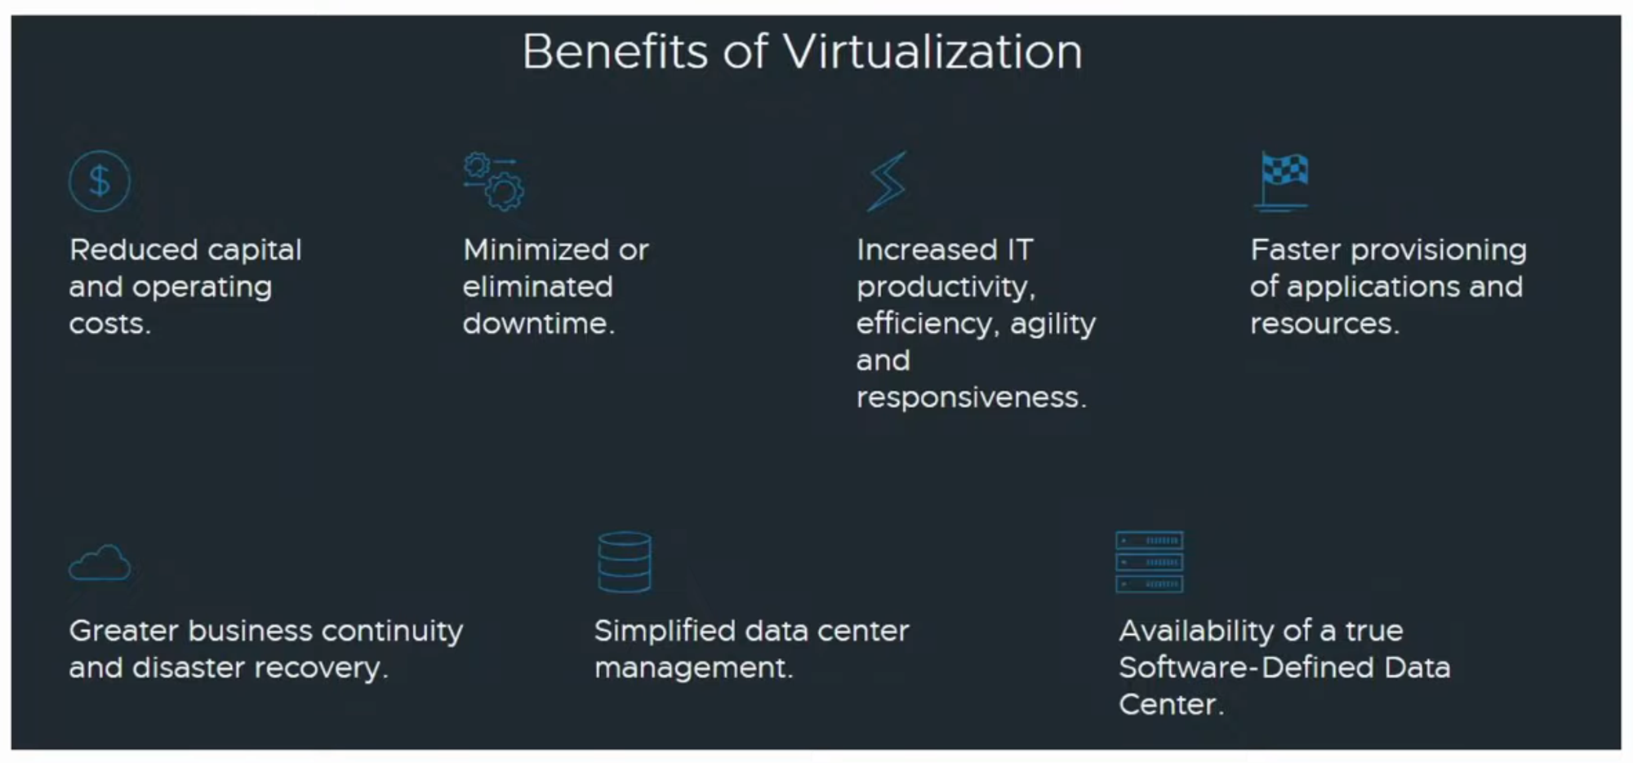

## **VIRTUAL NETWORKS**

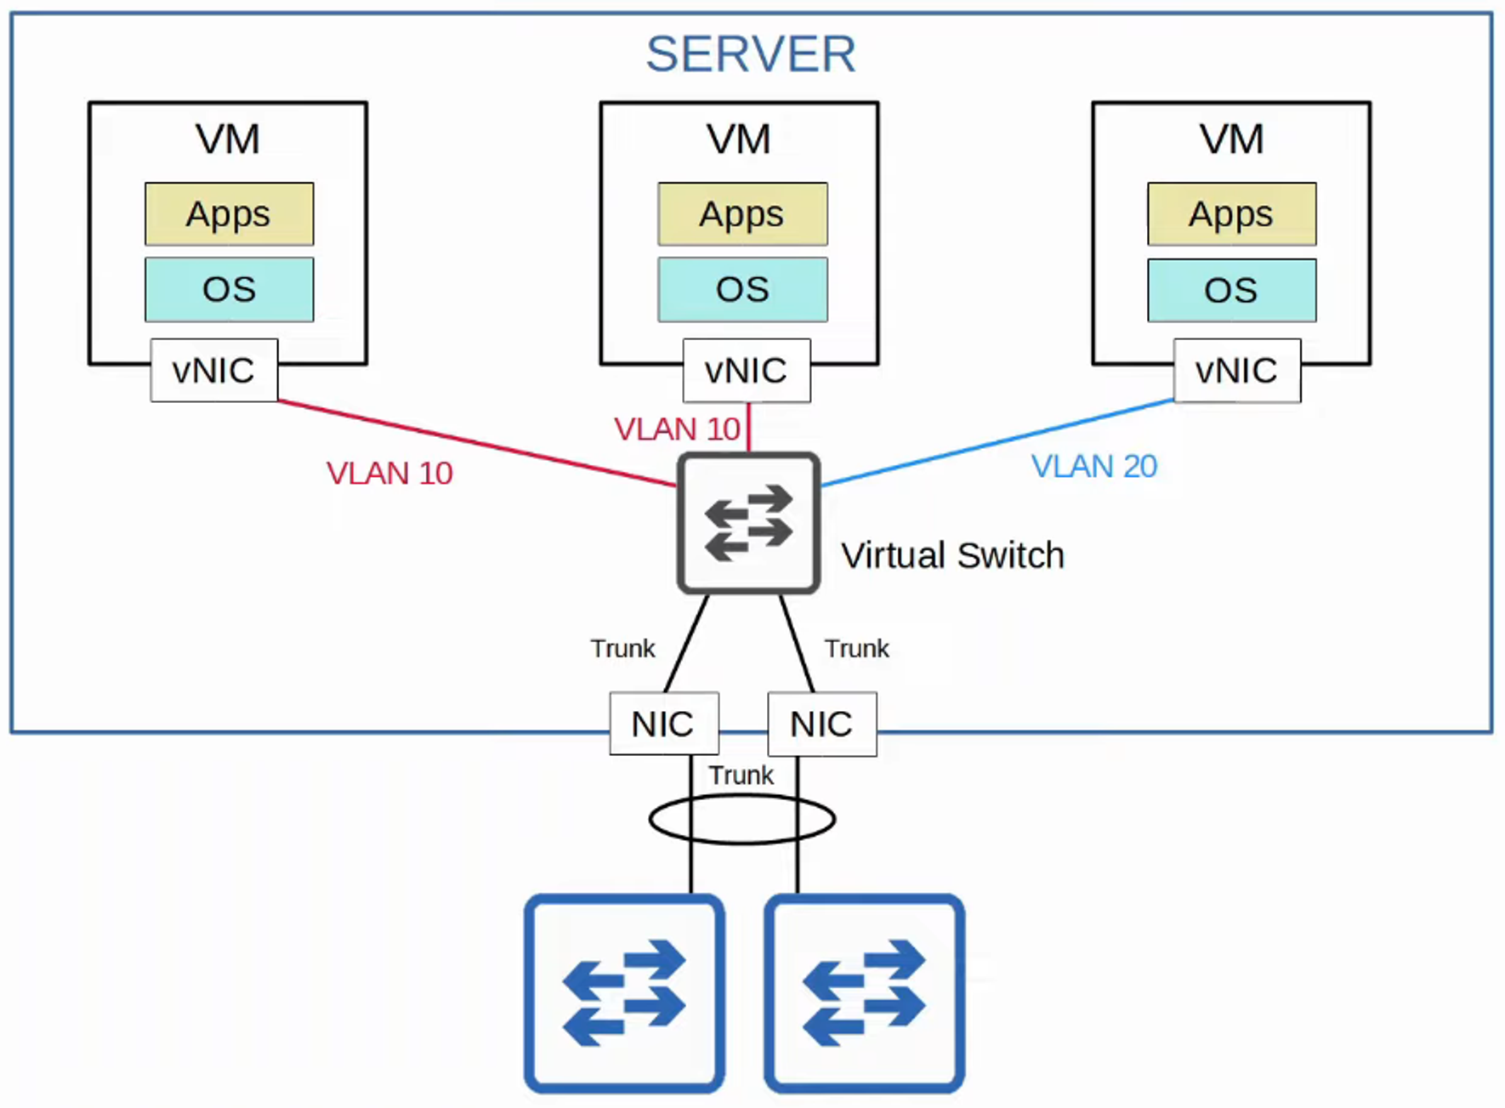

* **VMs** are connected via a **virtual switch (vSwitch)** running on the **hypervisor**.
* **vSwitch interfaces** act like **physical switch ports**, supporting **VLANs** for **Layer 2 segmentation**.
* **vSwitch interfaces** connect to the **physical NICs** of the server for **external network** communication.

## **INTRO TO CLOUD COMPUTING**

### **Traditional IT Infrastructure Deployments:**

* **On-Premises:**
  + All **servers, networking devices, and infrastructure** are located **on-site**.
  + The company **owns** and **maintains** all equipment.
  + Responsible for **power, cooling, and space**.
* **Co-Location:**
  + Renting **data center space** for infrastructure.
  + Data center provides **space, power, cooling**.
  + Customers maintain their **own hardware**.

**Cloud services** provide an **alternative** and are growing rapidly.

## **CLOUD SERVICES**

* Defined by **NIST (National Institute of Standards and Technology) SP 800-145**.

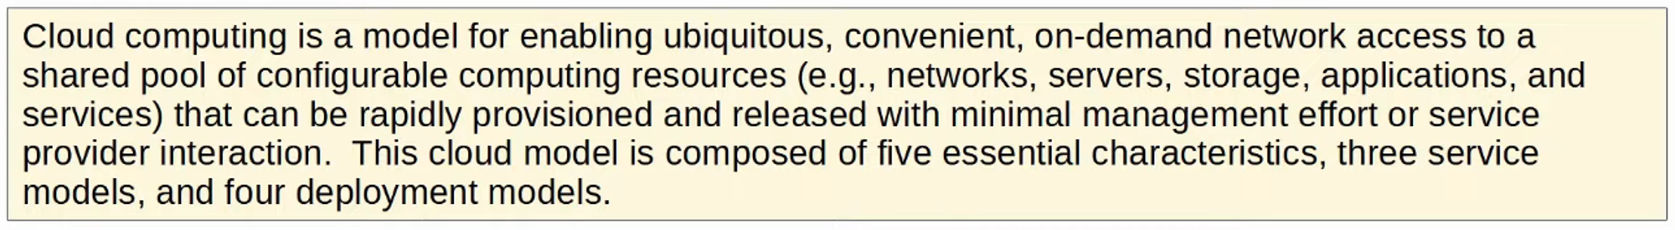

* **Cloud Computing** includes:
  + **Five Essential Characteristics**
  + **Three Service Models**
  + **Four Deployment Models**

## **THE FIVE ESSENTIAL CHARACTERISTICS OF CLOUD**

1. **On-Demand Self-Service** – Customers can **start/stop services** via a web portal.
2. **Broad Network Access** – Services accessible over **standard networks** (Internet, WAN).
3. **Resource Pooling** – Resources allocated dynamically from a **shared pool**.
4. **Rapid Elasticity** – Services can **expand/reduce** quickly as needed.
5. **Measured Service** – Customers **pay for usage** (e.g., per GB storage per day).

## **THE THREE SERVICE MODELS OF CLOUD**

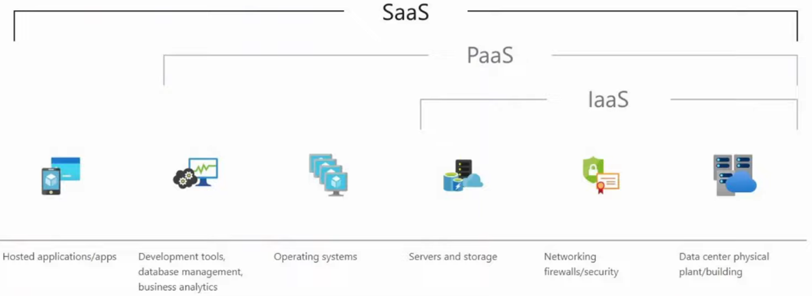

1. **Software as a Service (SaaS)** – Example: **MS Office 365**.
2. **Platform as a Service (PaaS)** – Examples: **AWS Lambda, Google App Engine**.
3. **Infrastructure as a Service (IaaS)** – Examples: **Amazon EC2, Google Compute Engine**.

## **DEPLOYMENT MODELS**

1. **Private Cloud** – Exclusive use by a **single organization**.
2. **Community Cloud** – Shared by **specific organizations** with common needs.
3. **Public Cloud** – Open to **multiple organizations** (AWS, Azure, GCP, etc.).
4. **Hybrid Cloud** – Combination of **private, public, and community cloud models**.

## **BENEFITS OF CLOUD COMPUTING**

* **Cost Savings** – Reduces **CapEx** for hardware and infrastructure.
* **Global Scale** – Cloud **resources scale dynamically**.
* **Speed & Agility** – Services are **on-demand** and **fast to deploy**.
* **Security & Compliance** – Built-in **security** and **regulatory compliance**.

# **REVIEW OF VIRTUAL MACHINES AND CONTAINERS**

## **Virtual Machines (VMs)**

### **Overview**

* VMs allow multiple operating systems to run on a single **Physical Server**.
* A **Hypervisor** is used to manage and allocate **Hardware Resources** to each VM.

### **Types of Hypervisors**

### **Key Characteristics**

* Each VM can run the same or different OS (Windows, Linux, macOS, etc.).
* **Bins/Libs** represent software libraries and services needed by the apps running inside the VM.
* Apps in VMs are isolated from each other.
* VMs are easy to create, delete, and migrate between physical servers.

### **Advantages**

* High level of **Isolation** between VMs.
* Portability between servers with the same hypervisor.
* Suitable for running **multiple OS environments** on the same hardware.

## **Containers**

### **Overview**

* Containers are **software packages** that include an **App** and its **dependencies** (**Bins/Libs**) required to run.
* Containers typically run **one app per container** (although multiple apps can be used).

### **Container Engines**

### **Key Characteristics**

* Containers run on a **Container Engine**, which operates on a **Host OS** (usually Linux).
* Lightweight and smaller in size compared to VMs.
* Ideal for **Microservices Architecture**.
* Easy to automate and scale using **Container Orchestrators**.

### **Advantages**

* Faster boot time (milliseconds).
* More portable across different environments.
* Efficient use of **CPU/RAM resources**.

## **Virtual Machines vs. Containers**

## **Summary**

* **VMs** are better for running **multiple OS environments** and high isolation needs.
* **Containers** are better for **lightweight, portable, and scalable applications**.

### **Diagram References**

* Type 1 and Type 2 Hypervisors
* Virtual Machines Architecture
* Containers Architecture
* Virtual Machines vs. Containers Comparison

# **VIRTUALIZATION (VRF)**

## **Introduction to VRF**

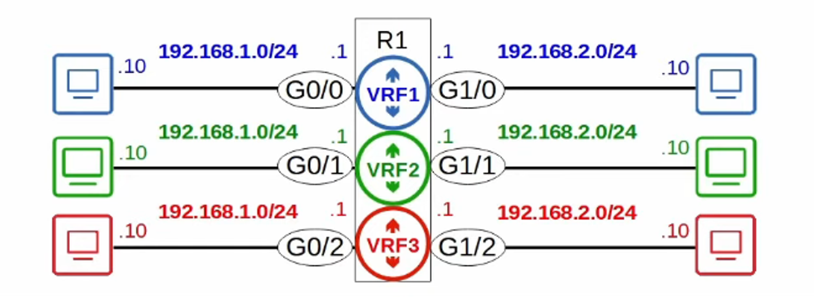

* **Virtual Routing and Forwarding (VRF)** divides a **single router** into **multiple virtual routers**.
  + Similar to how **VLANs** divide a **single switch** (LAN) into **multiple virtual switches** (VLANs).
* Achieves this by allowing a router to build **multiple separate routing tables**.
  + **Interfaces** (Layer 3 only) and **routers** are configured to be in a specific **VRF instance**.
  + **Router interfaces, SVIs, and routed ports** on multilayer switches can be configured in a VRF.
* **Traffic in one VRF cannot be forwarded** out of an interface in another VRF.
  + **Exception:** **VRF leaking** can be configured to allow traffic to pass **between VRFs**.
* **VRF is commonly used for MPLS (Multiprotocol Label Switching)**.
  + The focus here is **VRF-Lite** (VRF without MPLS).
* **Used by service providers** to allow **one device** to carry **multiple customers’ traffic**.
  + Each customer's traffic is **isolated** from others.
  + **Customer IP addresses can overlap** without conflicts.

## **VRF Configuration**

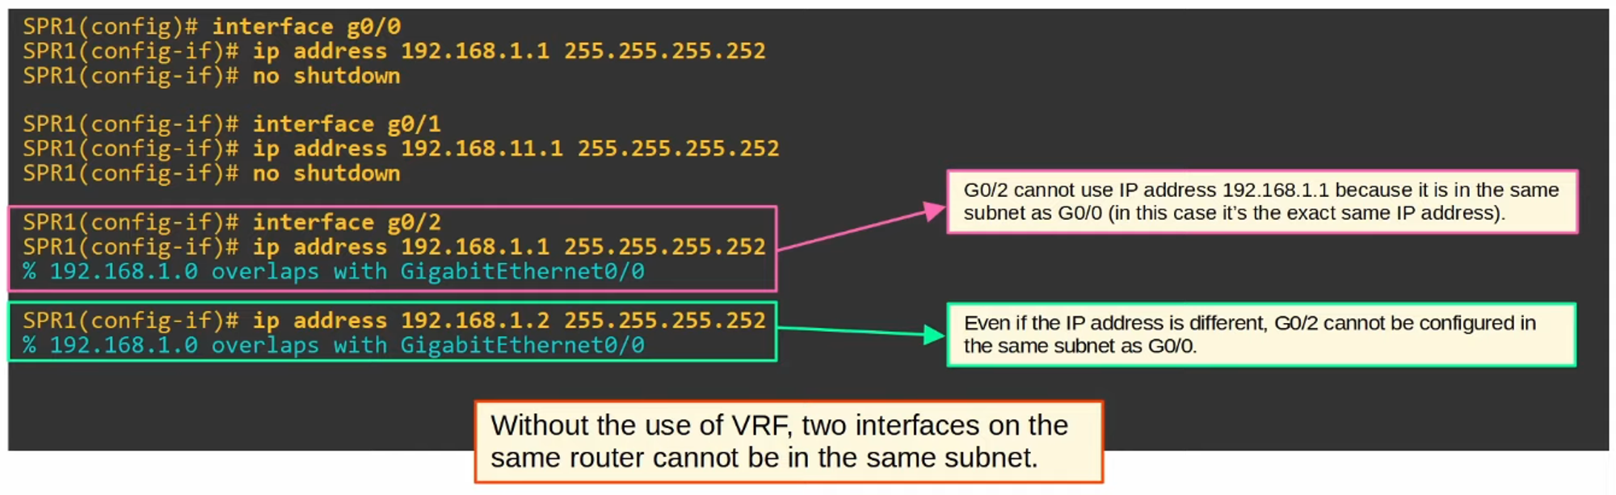

### **Creation and Configuration of VRFs**

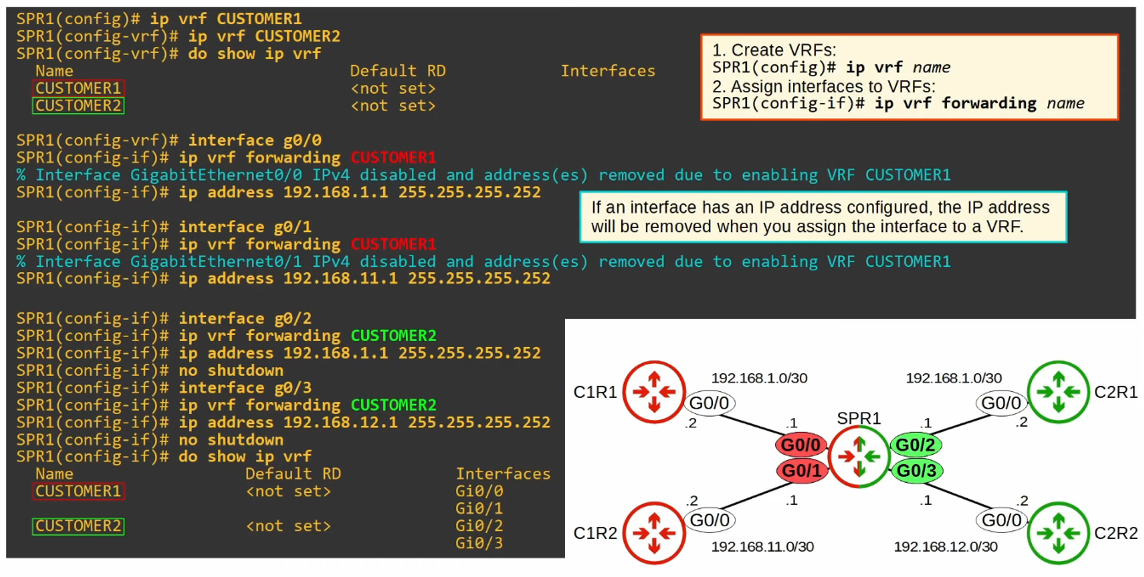

### **Viewing VRF Routing Table**

#### **Command: show ip route for VRFs**

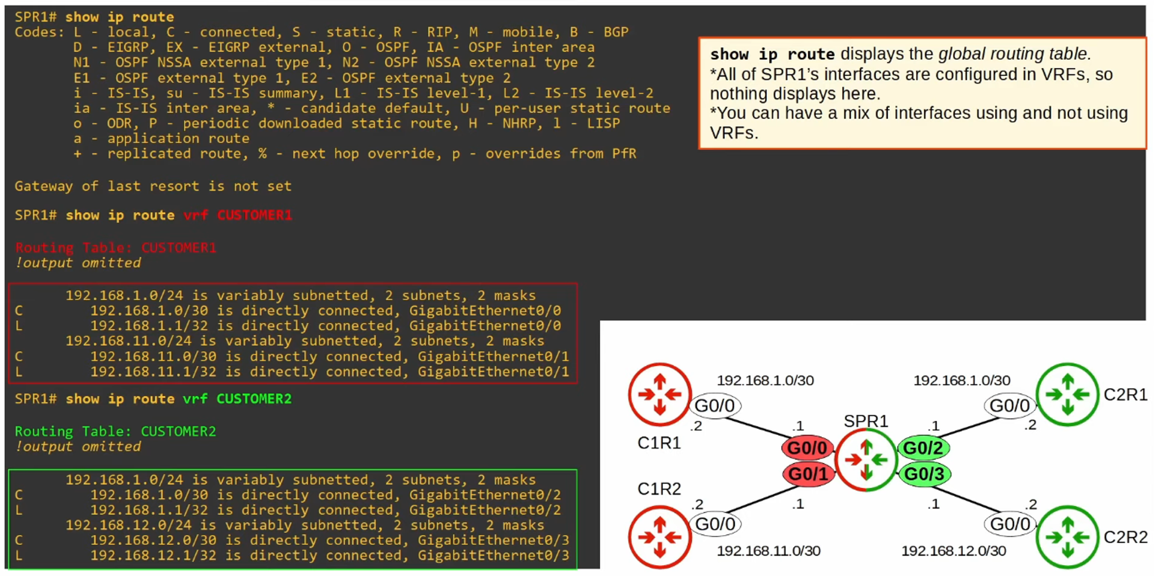

### **Testing VRF Connectivity**

#### **Command: ping other VRFs**

